Mariner's 23rd Psalm
The Lord is my pilot—I shall not drift.
He lights my passage
across dark channels.
He steers me through the deep waters;
He keeps my log.
He guides me by the North star
for my shipmate’s sake.
Yes, though I sail mid the thunders
and tempests of life,
I will fear no peril.
For Thou art with me;
Thy stars and Thy heavens,
They comfort me.
Surely fair winds and calm seas
shall follow me
All the days of my life;
And I will rest my oar in a
safe harbor, forever.
Amen.

Retirement Ceremony

Electronics Technician
Master Chief (Submarines)

Curtis Dean Haggard

United States Navy

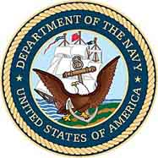

June 14th, 2002
Navy Memorial
USS Barry

