
"All hands on deck" was passed, speeches were made about great victories, battles fought upon the sea, raging storms weathered, and voyages to distant and strange lands with ports-of-call others only dream about.
The Boatswain would stand tall the sideboys, the retiree would request permission to go ashore - step to the platform and the sideboys would lower away. As the Jolly Boat pulled away, the gunner would fire a salute from the ship's main battery, the retiree sat in the stern sheets... going ashore.

We still stop all engines, lay about smartly, and drop anchor to pay homage to one of our shipmates going ashore. To honor the years served, the guidance, the leadership, the friendship and the expertise that this shipmate has freely given these 24 years.

Avast ye swabs, land’s in sight-make haste—for we land tonight.
At break of day we’ll man the rails and gangplank way.
The Bos’ns pipe will trill and shrill—as we send a shipmate to the shore, there to remain forever more. Tonight we’ll crack a keg or two, gather round and drink a toast to you. We’ll lift our mugs away up high, for the many years that drifted by.
Remember throughout the many years, you sailed away amidst the tears of loved ones left behind, worried and hoping they’d be fine.

Aye mates, for 24 years, Master Chief Haggard has stood the watch.
While some of us lay in our bunks at night... this man stood the watch. While others of us were attending school... this sailor stood the watch.
And yes, even before many of us were born... he stood the watch.
As our families watched storm clouds of war building on the horizons of history... the Master Chief stood the watch. Though he saw his family ashore, often needing his guidance... he still stood his watch.
For 24 years he has had the courage to honor his commitment... so that we and our fellow countrymen could sleep soundly, in safety, each night.

Today, we are here to say... "Shipmate, Well Done!"

"Master Chief, You Stand Relieved... We Have The Watch!"

Boatswain... Stand By To Pipe The Side... Shipmate Going Ashore.

6

Welcome

National Anthem
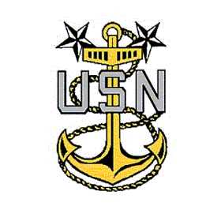

Speakers

Presentation of Awards

Remarks by Retiree

Benediction

Transfer To USS Barry for Reception

Speaker

Relieve The Watch

Going Ashore

3

