 Curtis D. Haggard graduated from the University of the State of New York in Albany, New York with a Bachelor of Science degree in Psychology, and from the Valdosta State University Graduate School in Valdosta, Georgia with a Master of Public Administration degree, where he was the 1993 Graduate Student of the Year. He also graduated with Military Honors from the Navy Senior Enlisted Academy in Newport, Rhode Island in 1995.
He entered the U.S. Navy in Las Vegas, Nevada and reported to Basic Training in San Diego, California in 1978. Upon completion of Electronics Technician A School at Great Lakes, Illinois he returned to San Diego for a six-month tour as a radar technician aboard the destroyer USS John R. Craig (DD 885). He next reported to Naval Nuclear Power School in Orlando, Florida and then to the Nautilus reactor plant prototype in Idaho Falls, Idaho.
Curtis arrived at Pearl Harbor, Hawaii in 1980 for duty in Reactor Controls Division aboard USS Tautog (SSN 639). He completed deployments to the Western and Eastern Pacific and Indian Ocean and to the North Pole. He qualified Engineering Watch Supervisor, Engineering Duty Petty Officer and Reactor Operator. In 1983, instructor duty followed at the Trident prototype in Ballston Spa, New York where he qualified Engineering Officer of the Watch and Engineering Duty Officer, certified Master Training Specialist and advanced to Chief Petty Officer.
He next reported to the initial manning of the Pre-Commissioning Unit Pennsylvania at the Electric Boat Shipyard in Groton, Connecticut in 1987. In 1989, the USS Pennsylvania (SSBN 735) commissioned in New London, Connecticut. He arrived with the Blue Crew in Kings Bay and completed a five-year tour, including three Strategic Deterrent Patrols.
His next duty station was the Trident Training Facility in Kings Bay, where he qualified Command Duty Officer. He was the Reactor Controls Division Officer in the Engineering Training Department and the Electronics Technician Maintenance School Supervisor.
Curtis reported to USS Hyman G. Rickover (SSN 709), homeported in Norfolk, Virginia, in August 1995 where he was the Engineering Department Master Chief. He completed two Operational Reactor Safeguards Examinations, two Tactical Readiness Evaluations and an extended deployment to the North Atlantic.
He arrived in Washington, DC as the Quality Control Advisor to the Deputy Chief of Naval Operations (DCNO M&P, the Nuclear Enlisted Community Manager) in May 1997.
Curtis sits on the Board of Directors of the U.S. Naval Institute and on the Board of Directors of the National Capital Area Chapter (NCAC) of the American Society for Public Administration (ASPA), and he is a member of the American Legion and Mensa organizations. He has been awarded the Navy Commendation Medal, Navy Achievement Medal (3 awards), Battle Efficiency Ribbon (4), Navy Good Conduct Medal (6), Navy Expeditionary Medal, National Defense Service Medal (2), Sea Service Ribbon, Arctic Service Ribbon, Navy Expert Pistol Medal, Enlisted Submarine Warfare Device (Dolphins) and Ballistic Missile Submarine Patrol Pin (3).
In 1982, he married the former Joni Flegal of Kalamazoo, Michigan who graduated from Western Michigan University with a Bachelor of Arts degree in Geography.
They live in Stafford, Virginia with their two sons, Randy (17) and Bobby (13).

2

The
Chief Petty Officer
Retirement Creed
You have on this day, experienced that which comes to all of us who serve on active duty in "OUR NAVY." I say "OUR NAVY," because your departure from active duty in no way terminates your relationship.
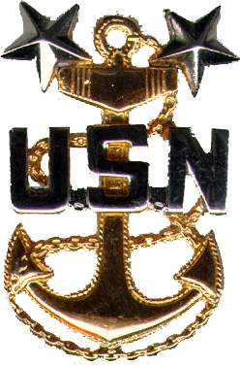
By law and tradition, U.S. Navy Retirees are always on the rolls ever ready to lend their service when the need arises. The respect that you earned as "The Chief" was based on the same attributes that you will now carry into retirement. You should have no regrets.
Do not view your retirement as an end of an era but rather as orders to a new and challenging assignment, to a form of independent duty.
Remember well that you have been, and will always be, an accepted member of the most exclusive of all fraternities - that of the U.S. Navy Chief Petty Officers. The active duty Chiefs salute you, your retired Chiefs welcome you.
I wish you the traditional:
"Fair Winds and Following Seas."

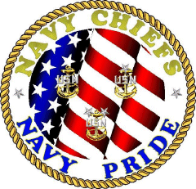
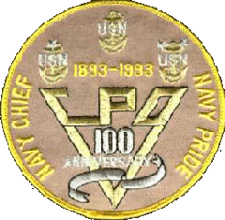
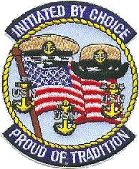
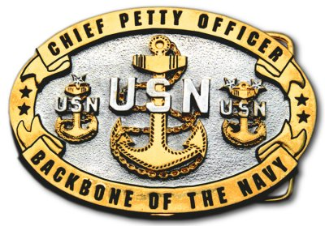
7

